**Effects of environmental complexity on Red dholes (*Cuon alpinus*)**

**Introduction**

Red Dholes (*Cuon alpinus;* henceforth referred to as dholes*)* go by a variety of names such as Asiatic wild dogs, howling dogs or whistling dogs due to their propensity to communicate with one another via whistling sounds, a sharp contrast from most other Canids who mainly communicate with conspecifics by barking. The dholes are known as habitat generalists due to their ability to survive in a wide variety of environments ranging from the dense tropical rainforests of South-east Asia to the temperate hilly regions of Nepal, Bhutan and Ladakh, Pakistan, situated 5,300m above sea level (Kamler *et.al*, 2015).

Despite their innate ability to adapt to various environments, dholes are listed as being endangered as per the IUCN Red List (Kalmer *et.al,* 2015) and are listed in Appendix II of CITES (CITES, 2021). Although dholes are not sought out for their parts to be sold in the traditional medicine black markets, these hypercarnivores indirectly face widespread anthropogenic threats (Kamler *et.al*, 2015)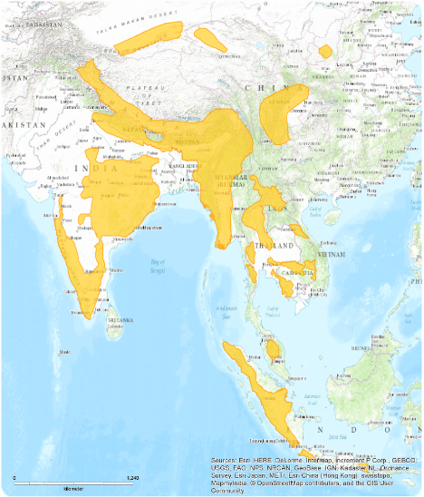

Figure 1: Geographic distribution of Red Dholes (Cuon alpinus) (Kalmer et al., 2015)

WAZA accredited zoological institutions aim to provide the animals under their care with enclosures that are not only appropriately sized, but that are also complex enough to stimulate the individuals housed frequently. Studies (Clubb & Mason, 2002; Clubb & Mason, 2007; Mason *et.al*, 2007), have shown that a lack of environmental complexity and/or stimuli leads to an increase in stereotypic behaviour as animals have an innate need to engage in species-specific behaviour. The prevalence of stereotypic behaviour not only affects the central nervous system and overall health of the individuals, but also increased mortality rates amongst new offspring (Clubb & Mason, 2007; Mason *et al.,* 2007; Maisch, 2010). As a result, this can affect a zoological institutions’ ability to collectively preserve and reintroduce threatened species.

Many institutions try to negate the lack of stimuli present in captive environments through a number of measures such as increasing environmental complexity and enclosure size, changes to feeding schedules, occupational therapy and most commonly, environmental enrichments (Mason *et.al*, 2007). Although environmental enrichments aid in reducing abnormal repetitive behaviours, they do not completely abolish them in the long term; signifying the importance in providing the right type of environment to the animals housed (Swaisgood & Shepardson, 2006; Mason *et.al,* 2007).

As such, taking into consideration the susceptibility of carnivores – namely those with large home ranges (Mason *et al.,* 2007) - towards displaying ARBs, this study was designed towards solely looking at how the presence of fixtures and fittings within an enclosure would affect the activity levels of the Red Dholes under our care. Here, we hypothesize that dholes, when moved into an enclosure that is more environmentally enriched (i.e., greater number of fixtures and fittings), will exhibit an increase in activity levels and patterns.

~~The hypothesize is stated below~~

1. ~~A larger space with the presence of more fixtures and fittings would lead to higher activity levels (Red Dhole Enclosure 1)~~
2. ~~A smaller space that does not contain any unessential fixtures and fittings would incur lower activity levels (Red Dhole Enclosure 2)~~

**Materials and Methods**

*Enclosures*

There are two different enclosures used for this report. The original enclosure will be referred to as Red Dhole Enclosure 1 (RD1) and the enclosure which the 6.0 group moved into will be referred to as Red Dhole Enclosure 2 (RD2) for the rest of this report. Both enclosures are located at Night Safari, Singapore (1°24'08.0" N 103°47'16.6" E). Red Dhole Enclosure 1 is 24.71% larger with a total area of 42.5 m2 (refer to Figure 2)whilst RD2 is slightly smaller with an area of 32 m2 (refer to Figure 3).

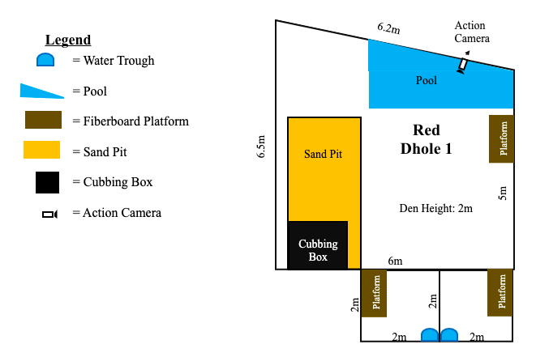

Figure 2: Layout of Red Dhole 1 enclosure including fixtures and fittings

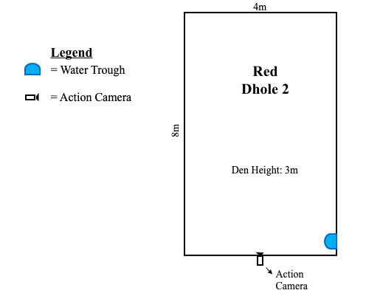

Figure 3: Layout of Red Dhole 2 including fixtures and fittings

Table 1: List of fixtures and fittings at Red Dhole 1

|  |  |
| --- | --- |
| **Red Dhole Enclosure 1** | |
| Water Trough | Enables provision of potable water to the animals |
| Pool | Permits animals to cool off on hot days; swimming; maintains hygiene |
| Fibreboard Platform | Perch points; resting area |
| Sand Pit | Permits digging and caching of food; latrine corner |
| Cubbing Box | Provides secure nursing area; warm resting space on cool nights |

Table 2: List of fixtures and fittings at Red Dhole 2

|  |  |
| --- | --- |
| **Red Dhole Enclosure 2** | |
| Water Trough | Enables provision of potable water to the animals |

Action cameras were used in this study to remotely observe and collect observational data as the presence of the Animal Care team would have affected their behaviours. A total of two action cameras were used interchangeably for this study - the Akaso v50 pro and the Akaso v50 pro SE, both of which share very similar technical specifications. The cameras were set at a height of around 2 m at both sites in order to easily capture and identify the behaviours of the dholes. <video recording settings; frequency and duration of each footage, resolution, also need details on how the video footages were processed.>

**Study subjects**

The Mandai Wildlife Group (MWG), Singapore, has a total of 11 dholes in its’ collection, all of whom are housed at the Night Safari in two different groupings (5.1 & 6.0). From their arrival up until mid-2021, both groups were housed in the same enclosure (RD1?), and were released out into the exhibit on alternating nights. In June 2021, the 6.0 group was moved into a different enclosure (RD2) that used to house the Indian Wolves. The only major shortcoming of the new enclosure was that it was quite bare in comparison to their previous den area. As highly social animals, the need of wide and big enclosure space is important for their welfare, along with environmental enrichments/complexity that are useful for the animals (Taylor, 2022; Mason *et,* 2007).

This study will only be looking at the 6.0 group of individuals as it was only this group that was translocated from RD1 to RD2. The 4.1 group remains at RD1.

**Sampling regimes**

Sampling methods used were focal and time sampling. The animal’s behaviours were observed for 10 minutes each day between 1500 to 1800 hrs. Their behaviours were recorded at intervals of 30 seconds with there being a total of 120 counts per day for all six dholes. A total of 2160 data points were collected across 18 days for each enclosure type.

Since this study holistically looks at the total amount of activity and inactivity, the individual behaviours in the ethogram were further split up into active and inactive states accordingly (refer to Table 3) for us to better examine their behaviours.

The ethograms are divided into three states; active, inactive and OOS as shown in Table 3

Table 3: List of behaviours and their descriptions

|  |  |  |
| --- | --- | --- |
| **Behaviour** | **Key** | **Description** |
| **Active** | | |
| Chewing | C | Chewing on objects |
| Defecating | De | Animal seen defecating or urinating as part of its’ normal biological processes (not scent marking) |
| Feeding | F | Feeding or drinking |
| Grooming | Gr | Grooming oneself |
| Interaction | In | Grooming conspecifics/ asserting dominance/ play/ pawing at conspecific/ smelling conspecific |
| Licking | L | Licking objects |
| Locomotion | Lo | Moving/Running/Walking around the enclosure |
| Pawing | P | Pawing or scratching an object |
| Rubbing | Ru | Rubbing onto or rolling over objects |
| Scent Marking | Scm | Scent marking conducted via excrements |
| Smelling | Sm | Smelling or sniffing at objects |
| Stretching | Str | Stretching |
| **Inactive** | | |
| Sleeping | Sl | Animal lying down on all fours, its’ back or sides; seen sleeping or resting awake |
| Stationary | S | Animal sittingon hind legs /standing still |
| **OOS** | | |
| Out of sight | OOS | Unable to see animal completely or unable to determine behaviour of individual |

The data was analysed using Microsoft Excel. Stacked bar graphs were plotted to see the activity, inactivity and OOS levels of the dholes between the two enclosures. R2 is calculated using Excel and the formula for correlation is as follow:

$$R = \frac{nΣxy-ΣxΣy}{\sqrt{n}Σx^{2}-{\left(Σx\right)}^{2}\left[nΣy^{2}-{\left(Σy\right)}^{2}\right]}$$

*n* = number of pairs of scores

Σ*xy* = sum of the products of paired scores

Σ*x* = sum of *x* scores

Σ*y* = sum of *y* scores

Σ*x*2 = sum of squared *x* scores

Σ*y*2 = sum of squared *y* scores

**Results**

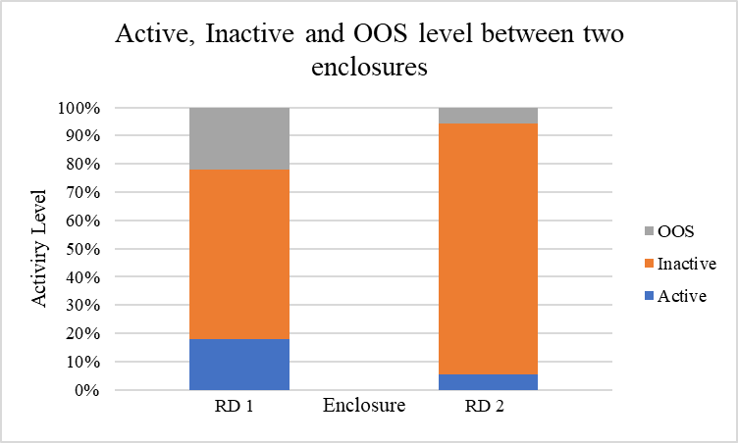

Figure 4: Representation of activity, inactivity and OOS levels across both enclosures

Based on the observations, the dholes were more active in RD1 than RD2 (R2 = 0.298). The dholes were 12.5% more active at RD1 (18.01%) than RD2 (5.51%). The active states that have high count in RD1 enclosure comprised of inter-specific interactions (24 counts), locomotive (341 counts) and grooming (10 counts). The active behaviours for dholes in RD2 were slightly different, they were seen smelling (17 counts) and running (95 counts) around for most of the observation days with few counts of defecating (3 counts) and grooming (2 counts) as shown in Appendix 1.

Inactivity levels were higher at RD2 as compared to RD1 with differences of 28.7% (R2 = 0.023). The animals were seen resting a total of 1887 counts at RD2 as opposed to the 1296 counts from RD1 . The animals were also seen displaying more stationary behaviour (29 counts) at RD2 contrasted by zero counts observed at RD1. OOS counts were lower in RD2 compared to RD1 with differences of 16.2% as there is less hiding space for the dholes in the enclosure.

**Limitations**

Due to the presence of fixtures such as the cubbing box and the overall design of RD1 leaving quite a few blind spots, OOS occurrences were quite high. For the purpose of this study, we decided to omit data from days where the OOS incidents were above 40 out of a total of 120 counts. Across the entire 18 days of data collected, RD1 had a total of 475 counts of OOS occurrences (21.99%) in comparison to the 125 counts (5.79%) observed at RD 2.

Another limitation would be the amount of time spent at the enclosures prior to the study being conducted. The dholes from the 6.0 group spent about 8 to 10 years at RD 1 which would have given them ample time to acclimatise and territorialise the enclosure. The group was transferred out in June 2021 and observations began in October 2021 which would have given them about 4 months to acclimatise to their new surroundings. Although staff observed the dholes to have taken quite quickly to their new surroundings, the time frame given to territorialise prior to the study in their new environment was significantly shorter. Increased instances of investigative behaviours such as smelling and scanning (stationary) could support these claims.

Another cause for the increase in investigative behaviours could also be the on-going construction for the upcoming parks under MWG that is in close proximity to RD 2. The loud sounds and movement of personnel could have led to increases in certain investigative behaviours. However, reviews on the footage showed no inhibitions to the loud sounds, dust and non-care team personnel. Data collected also showed no likely signs of stereotypy and as such the effects of the construction on the study was deemed to be negligible.

Dholes are understudied which has resulted in there being a lack of information available on their intricate behaviours and social dynamics. As such this paper will also look towards using information derived from studies on the African Painted Dogs and New Guinea Bush Dogs to substantiate our findings as these two Canid species are the most similar to the Dholes in terms of their social dynamics, behaviours and even morphological adaptation.

**Discussion**

Environmental complexity is a major component in the provision of welfare for captive animals. As animals in the wild face an everchanging environment they are met with challenges such as “predators, food shortage, social competition and intricacies, weather, illness” (Spinka and Wemelsfelder, 2011), all of which affect their chances of survival and reproduction. By facing these challenges, wild animals are forced “to engage actively with the environment with the main purpose of gathering knowledge and enhancing its skills for future use”, (Spinka and Wemelsfelder, 2011), an opportunity that captive animals are not frequently presented with.

The Dholes displayed greater active and reduced inactive behaviors in the complex environment of the RD 1 enclosure. A study conducted by Price (2010), on the activity levels of African Painted Dogs when presented with enrichments illustrated that animals were active not only on the day itself but also the days after when both data sets were compared with the day before the enrichment was given (baseline data). High count in locomotion would also mean they need more space to spend the energy as it was recorded that dhole have high distribution in forested areas (Widodo *et.al*, 2020), that can provide them with the opportunity of finding new resources (Spinka and Wemelsfelder, 2011).

As the dholes were habituated to staying in their original enclosure for a long period of time, a reduced amount of smelling/sniffing behaviors were observed in their daily activities as they were not very much interested in investigating their surroundings. However, this behavior was observed quite often in the new enclosure as the dholes were interested and curious about their environment. Sniffing the air provides a lot of information for the animals such as finding resources, mate and avoiding predators. When there is no opportunity for the animals to express this behavior, it might lead to a monotonous and stressful lifestyle which eventually could affect their biological functions (Pritchett-Corning, 2019).

As stated by Caspar (2016), on the occasion where the subjects are stationary and staring with no purpose observed, there is a possibility of animals experiencing stereotypic behavior. Captive animals, especially social animals, need platforms, cubbing dens and sandpits to help them live in a controlled environment in order for them to express species-specific behaviors (Caspar, 2016). Although the increased counts of stationary behavior observed from the 6.0 group could be indicative of stereotypy (Caspar, 2016), considering their relative unfamiliarity to RD 2, there is an increased likelihood that these are investigative behaviors displayed by the dholes who may be scanning unfamiliar territory.

Even though most literature on *C. alpinus* indicate that they are diurnal (Rasphone *et.al*, 2020; Kamler *et.al*, 2015), the high inactivity levels were mainly derived from sleeping and resting behaviors observed during the day. The data collection also was influenced by workload and manpower, thus the time frames were chosen at random based on what timings could conveniently be allocated as per the section's workflow for that day. Besides, considering how they mainly go out on display at night - where more enrichments, token feedings and interactions happen – there is a possibility that the dholes at the Night Safari are more active during those hours.

**Future Directions**

As previous studies before (Price, 2010; Špinka, & Wemelsfelder, 2011), the findings from this study indicate that the presence of stimuli does lead to an increase in active behaviors seen. Whilst most other studies seem to rely on the usage of enrichments as stimuli, for this paper the stimuli were derived from the fixtures and fittings present in the enclosures. Although fixtures and fittings are comparatively more permanent than enrichment devices – implying that the novelty of interacting with the fixtures are not as strong as the occasional enrichment device - they still seemed to elicit more activity from the subjects in this study.

The information derived from this paper will ultimately be used to improve the conditions under which the Dholes are housed at MWG. At present, the section also has plans to further investigate their behaviours out in the exhibit with stimulus in the form of enrichment devices. The data collected from this study will be used to support the findings of future studies on our Dholes as well.

**References**

Caspar, G. (2016). Fact Sheet: Environmental Enrichment. Greyhound Racing NSW. Pp 1-5

Clubb, R., & Mason, G. J. (2007). Natural behavioural biology as a risk factor in carnivore welfare: How analysing species differences could help zoos improve enclosures. *Applied Animal Behaviour Science*, *102*(3-4), 303–328. <https://doi.org/10.1016/j.applanim.2006.05.033>

*Asiatic wilddog*. CITES. (2021, January 12). Retrieved from https://cites.org/fra/gallery/species/mammal/Asiatic_wilddog.html

Ghaskabdi, P., Habib, B. & Qureshi, Q. (2016). A whistle in the woods: an ethogram and activity budget for the dhole in central India. Journal of Mammalogy 97(6): 1745- 1752. DOI: Need to find DOI

Kamler, J. F., Johnson, A., Vongkhameng, C., & Bousa, A. (2012). The diet, prey selection, and activity of dholes (Cuon alpinus) in northern Laos. Journal of Mammalogy 93(3): 627-633. DOI: 10.1644/11-MAMM-A-241.1

Kamler, J.F., Songsasen, N., Jenks, K., Srivathsa, A., Sheng, L. & Kunkel, K. 2015. Cuon alpinus. The IUCN Red List of Threatened Species 2015: e.T5953A72477893. <http://dx.doi.org/10.2305/IUCN.UK.2015-4.RLTS.T5953A72477893.en>

Laura J. Price, A preliminary study of the effects of environmental enrichment on the behaviour of captive African wild dogs (*Lycaon pictus*), *Bioscience Horizons: The*  *International Journal of Student Research*, Volume 3, Issue 2, June 2010, P ages 132–140, <https://doi.org/10.1093/biohorizons/hzq017>

Mason, G., Clubb, R., Latham, N., & Vickery, S. (2007). Why and how should we use environmental enrichment to tackle stereotypic behaviour? *Applied Animal Behaviour Science*, *102*(3-4), 163–188. <https://doi.org/10.1016/j.applanim.2006.05.041>

Pritchett-Corning, K., R. (2019). Environmental Complexity and Research Outcomes. ILAR Journal 60(2): 239-251. DOI: 10.1093/ilar/ilaa007

Rasphone, A., Kamler, J. F., & Macdonald, D., W. (2020). Temporal partitioning by felids, dholes and their potential prey in northern Laos. Mammal Research 65: 679- 689. DOI: <https://doi.org/10.1007/s13364-020-00524-9>

Špinka, M., & Wemelsfelder, F. (2011). Environmental challenge and animal agency. Animal welfare. Wallingford, UK: CAB International. p, 27-44.

Swaisgood, R., & Shepherdson, D. (2006). Environmental enrichment as a strategy for mitigating stereotypies in Zoo Animals: A literature review and meta-analysis. *Stereotypic Animal Behaviour: Fundamentals and Applications to Welfare*, 256–285. <https://doi.org/10.1079/9780851990040.0256>

Taylor, P.S.; Hemsworth, P.H.; Rault, J.-L. Environmental Complexity: Additional Human Visual Contact Reduced Meat Chickens’ Fear of Humans and Physical Items Altered Pecking Behavior. Animals 2022, 12, 310. DOI: <https://doi.org/10.3390/ani12030310>

Widodo, F. A., Sunarto, Hartoyo, D., Gunawan, Fadhli, N., Sukmantoro, W., Zulfahmi, Septayuda, E., & Adzan, G. (2020). Preliminary assessment of abundance and d istribution of Dholes Cuon alpinus in Rimbang Baling and Tesso Nilo landscapes, Sumatra. *Raffles Bulletin of Zoology* 68: 387 – 395. DOI: 10.26107/RBZ-2020-0055

**Appendices**

**Appendix I: Compilation of Ethograms from Red Dhole Enclosure 1**

|  |  |  |  |  |  |  |  |  |  |  |  |  |  |  |  |  |  |  |
| --- | --- | --- | --- | --- | --- | --- | --- | --- | --- | --- | --- | --- | --- | --- | --- | --- | --- | --- |
|  | | |  |  |  |  |  |  |  |  |  |  |  |  |  |  |  |  |
| **Day** | **C** | **De** | **F** | **Gr** | **In** | **L** | **Lo** | **OOS** | **P** | **Ru** | **S** | **Scm** | **Sl** | **Sm** | **Str** | **T** | **Vo** | **Total Data Points** |
| Day 1 |  |  |  |  | 2 |  | 3 | 26 |  |  |  |  | 87 | 2 |  |  |  | 120 |
| Day 2 |  |  |  |  | 5 |  | 11 | 35 |  |  |  |  | 69 |  |  |  |  | 120 |
| Day 3 |  |  |  |  |  |  | 5 | 17 |  |  |  |  | 98 |  |  |  |  | 120 |
| Day 4 |  | 1 |  | 1 | 2 |  | 34 | 38 |  |  |  |  | 44 |  |  |  |  | 120 |
| Day 5 |  | 2 |  |  | 1 |  | 3 | 32 |  |  |  |  | 82 |  |  |  |  | 120 |
| Day 6 |  |  |  |  |  |  |  | 22 |  |  |  |  | 98 |  |  |  |  | 120 |
| Day 7 |  |  |  |  | 1 |  | 28 | 31 |  |  |  |  | 60 |  |  |  |  | 120 |
| Day 8 |  |  |  |  |  |  | 39 | 33 |  |  |  |  | 48 |  |  |  |  | 120 |
| Day 9 |  |  |  | 4 |  |  | 8 | 14 |  |  |  |  | 94 |  |  |  |  | 120 |
| Day 10 |  |  |  |  |  |  | 12 | 38 |  |  |  |  | 68 | 2 |  |  |  | 120 |
| Day 11 |  |  |  | 1 | 4 |  | 13 | 15 |  |  |  |  | 87 |  |  |  |  | 120 |
| Day 12 |  | 1 |  |  | 4 |  | 9 | 25 |  |  |  |  | 81 |  |  |  |  | 120 |
| Day 13 |  |  |  | 1 |  |  | 34 | 29 |  |  |  |  | 56 |  |  |  |  | 120 |
| Day 14 |  |  |  |  |  |  | 66 | 35 |  |  |  |  | 18 | 1 |  |  |  | 120 |
| Day 15 |  |  |  |  |  |  | 6 | 36 |  |  |  |  | 78 |  |  |  |  | 120 |
| Day 16 |  | 2 |  |  |  |  | 49 | 32 |  |  |  |  | 37 |  |  |  |  | 120 |
| Day 17 |  |  |  | 3 | 1 |  | 19 | 17 |  | 3 |  |  | 77 |  |  |  |  | 120 |
| Day 18 |  |  |  |  | 4 |  | 2 |  |  |  |  |  | 114 |  |  |  |  | 120 |
| Totals (18) | 0 | 6 | 0 | 10 | 24 | 0 | 341 | 475 | 0 | 3 | 0 | 0 | 1296 | 5 | 0 | 0 | 0 | 2160 |

**Appendix II: Compilation of Ethograms from Red Dhole Enclosure 2**

|  |  |  |  |  |  |  |  |  |  |  |  |  |  |  |  |  |  |  |
| --- | --- | --- | --- | --- | --- | --- | --- | --- | --- | --- | --- | --- | --- | --- | --- | --- | --- | --- |
| **Date** | **C** | **De** | **F** | **Gr** | **In** | **L** | **Lo** | **OOS** | **P** | **Ru** | **S** | **Scm** | **Sl** | **Sm** | **Str** | **T** | **Vo** |  |
| Day 1 |  |  |  |  |  |  |  |  |  |  |  |  | 120 |  |  |  |  | 120 |
| Day 2 |  |  |  |  |  |  |  |  |  |  |  |  | 120 |  |  |  |  | 120 |
| Day 3 |  |  |  |  |  |  |  | 20 |  |  | 1 |  | 99 |  |  |  |  | 120 |
| Day 4 |  |  |  |  |  |  | 1 | 3 |  |  | 3 |  | 112 | 1 |  |  |  | 120 |
| Day 5 |  |  |  |  |  |  |  |  |  |  |  |  | 120 |  |  |  |  | 120 |
| Day 6 |  | 1 |  |  |  |  |  |  |  |  |  |  | 117 | 2 |  |  |  | 120 |
| Day 7 |  |  |  | 2 |  |  | 3 | 9 |  |  | 2 |  | 101 | 3 |  |  |  | 120 |
| Day 8 |  |  |  |  |  |  | 5 | 9 |  |  | 4 |  | 99 | 3 |  |  |  | 120 |
| Day 9 |  |  |  |  |  |  | 6 | 20 |  |  | 2 |  | 92 |  |  |  |  | 120 |
| Day 10 |  | 1 |  |  |  |  | 16 | 21 |  |  | 1 |  | 80 | 1 |  |  |  | 120 |
| Day 11 |  |  |  |  |  |  | 2 | 25 |  |  | 1 |  | 90 | 2 |  |  |  | 120 |
| Day 12 |  |  |  |  |  |  | 1 |  |  |  | 3 |  | 115 | 1 |  |  |  | 120 |
| Day 13 |  |  |  |  | 2 |  | 10 | 7 |  |  | 1 |  | 97 | 3 |  |  |  | 120 |
| Day 14 |  |  |  |  |  |  | 12 |  |  |  | 1 |  | 107 |  |  |  |  | 120 |
| Day 15 |  |  |  |  |  |  | 7 | 4 |  |  | 5 |  | 103 | 1 |  |  |  | 120 |
| Day 16 |  |  |  |  |  |  | 22 | 5 |  |  | 3 |  | 90 |  |  |  |  | 120 |
| Day 17 |  |  |  |  |  |  | 2 |  |  |  | 1 |  | 117 |  |  |  |  | 120 |
| Day 18 |  | 1 |  |  |  |  | 8 | 2 |  |  | 1 |  | 108 |  |  |  |  | 120 |
| Totals (18) | 0 | 3 | 0 | 2 | 2 | 0 | 95 | 125 | 0 | 0 | 29 | 0 | 1887 | 17 | 0 | 0 | 0 | 2160 |